Supplementary Material

Cellular Uptake and Distribution of Black Phosphorus Nanosheets in A549 cells: Effects on Cellular Metabolism and Mitochondrial Function

Yunsong Xu¹, Zhiyu Zhu¹, Xiaoyan Sun², Kun Lu³, Shipeng Dong¹, Boyang Huang¹, Pengfei Xue¹, Liuqing Zhao⁴, Zong Yang⁴, Liang Mao^{1,} *

¹State Key Laboratory of Pollution Control and Resource Reuse, School of the Environment, Chemistry and Biomedicine Innovation Center, Nanjing University, Nanjing 210093, China
² Nanjing Qixia District Hospital, Nanjing 210033, China
³School of Environmental Science and Engineering, Zhejiang Gongshang University, Hangzhou 310018, China
⁴SCIEX, Analytical Instrument Trading Co., Ltd., Shanghai 201100, China

*Corresponding author: Liang Mao, Email: lmao@nju.edu.cn

Information About ELECTRONIC SUPPLEMENTARY MATERIAL

FITC loading and fluorescence stability of BPNS-BSA-FITC
To explore the FITC loading of LBPNS-BSA-FITC and SBPNS-BSA-FITC, firstly, a standard curve correlating the concentration of BSA-FITC with UV-Vis absorbance needs to be established using the VARIAN Cary 50 Conc UV-Vis spectrophotometer (Agilent Company, America). Subsequently, the LBPNS-BSA-FITC or SBPNS-BSA-FITC (100 μg) obtained during the preparation process, before washing, was centrifuged twice at 12000 rpm. The UV absorbance at 490 nm of the supernatant after each wash was measured using the same UV-Vis spectrophotometer. The mass of BSA-FITC washed off during each wash was then calculated based on the standard curve. Finally, the FITC loading capacity (LC) of LBPNS-BSA-FITC or SBPNS-BSA-FITC was determined using these data.
$$\text{FITC LC }(μ\text{g/ }μ\text{g})=\frac{\text{Total weight of FITC-Weight of FITC in two washes}}{\text{Total weight of BPNS}}$$
To investigate the fluorescence stability of BPNS-BSA-FITC, a solution of BPNS-BSA-FITC (2 mL, 8 μg/mL) was stored in a dark environment. At various time points, the fluorescence intensity (Ex =490 nm, Em = 520 nm) was measured using a HITACHI F-7000 fluorescence spectrophotometer (HITACHI Company, Japan).
To assess the stability of FITC loading in BPNS-BSA-FITC, the fluorescence intensity of a solution containing BPNS-BSA-FITC (2 mL, 3 μg/mL) was measured using the HITACHI F-7000 fluorescence spectrophotometer (HITACHI Company, Japan). After specified time intervals, BPNS-BSA-FITC was collected by centrifugation at 12000 rpm and re-dispersed in 2 mL ultrapure water. The fluorescence intensity was then re-measured using the HITACHI F-7000 fluorescence spectrophotometer and compared with the initial values.

The TEM images showing cellular uptake of LBPNS and SBPNS
Cells were seeded in a 6-well plate at a density of 15×10⁴ cells per well and cultured for 24 h. Following this, the cells were exposed to either LBPNS-BSA-FITC or SBPNS-BSA-FITC (10 μg/mL) for an additional 24 h. After exposure, the cells were washed three times with phosphate-buffered saline (PBS) and then harvested. The collected cells were fixed overnight in a 2.5 % glutaraldehyde solution at 4 °C, followed by treatment with a 1 % osmium tetroxide solution for 1-2 h. Upon fixation, the samples were dehydrated using a series of ethanol solutions with increasing concentrations (30 %, 50 %, 70 %, 80 %, 90 %, and 100 %), with each concentration treated for 15 min. The permeated samples were subsequently embedded in molds and subjected to a gradient heating process. Afterward, the samples were sliced into sections of 70 -90 nm thickness. These sections were then stained with uranyl acetate solution for 15 min and lead citrate for 5 min before being air-dried. Transmission electron microscopy imaging of the cell sections was conducted using a JEOL JEM-1200EX (JEOL Company, Japan) to visualize the BPNS within the cells.

The CCK-8 cell toxicity of ingestion inhibitors
Cells were seeded at a density of 5×10³ cells per well in a 96-well plate. After 24 h of incubation, cells were treated for 2 h with the following regimen: Amiloride (40 μg/mL), MβCD (2 mM), and Dynasore (3 μg/mL) incubated at 4 °C. Following incubation, the cells were washed three times with phosphate-buffered saline (PBS). Subsequently, 100 μL of cell culture medium (F12K) was added to each well. According to the manufacturer's instructions, 10 μL of cell viability assay reagent (CCK-8) was added to each well, and the plate was incubated at 37 °C in darkness for 2 h. After incubation, the absorbance at 450 nm was measured using an Infinite M200PRO microplate reader (TECAN Company, Switzerland) to assess cell viability.

The TEM images and elemental dot mapping of SBPNS and LBPNS distribution within cells
Cells were seeded at a density of 15×10⁴ cells per well in a 6-well plate and cultured for 24 h. Following this, they were exposed to either LBPNS-BSA-FITC or SBPNS-BSA-FITC (10 μg/mL) for 24 h. After the exposure period, the cells were washed three times with phosphate-buffered saline (PBS). Subsequently, they were treated with trypsin for 1 min and then collected by centrifugation at 1000 rpm. The collected cells were processed according to the preparation protocol used in the uptake experiment. For observation of cellular organelles, transmission electron microscopy imaging was performed using a JEOL JEM-1200EX (JEOL Company, Japan). Additionally, elemental analysis of the cell slices was conducted using a FEI TecnaiG2 F30 (FEI Company, America).

Labeling Method and Characterization of BPNS with Gold Nanoparticles
The sodium citrate solution (20 μL, 0.3 mol/L) and tetrachloroauric acid solution (25 μL, 10 mmol/L) were added to the LBPNS dispersion (1 mL, 100 μg/mL) and stirred for 10 min. The mixture was centrifuged at 12,000 rpm for 15 min and washed with oxygen-free ultrapure water via centrifugation. The precipitated product obtained after centrifugation was designated as LBPNS-Au. The precipitated product prepared using SBPNS was named SBPNS-Au.
BPNS and BPNS-Au were dispersed in anhydrous ethanol and placed in an ultrasonic cleaner for 1 h to ensure uniform dispersion. A 0.5 mL aliquot of the dispersion was transferred to the surface of smooth aluminum foil using a pipette. After the sample was air-dried at room temperature, the aluminum foil was cut into squares (1 cm × 1 cm) and adhered to conductive tape on the sample stage. The samples were observed under a scanning electron microscope (SEM) at a pressure of 1×e⁻³ Pa and an accelerating voltage of 20 kV. Energy-dispersive X-ray spectroscopy (EDS) elemental mapping was subsequently performed to analyze nitrogen (N), oxygen (O), phosphorus (P), and gold (Au). The transmission electron microscopy (TEM) characterization of BPNS-Au followed the same procedure as described above.
BPNS and BPNS-Au were dispersed in pure water and placed in an ultrasonic cleaner for 1 h to achieve uniform dispersion. A 2 mL aliquot of the dispersion was transferred to a quartz cuvette using a pipette. The UV-Vis absorption spectra of the samples were subsequently recorded within the wavelength range of 400 nm to 800 nm.

Determination of the loading amount of gold nanoparticles on BPNS
The BPNS-Au solution (1 mL, 100 μg/mL) was centrifuged at 12,000 rpm for 20 min to obtain the BPNS-Au precipitate. The precipitate was digested in 461 μL of concentrated nitric acid (65 %) for 48 h. After digestion, the solution was diluted to a working solution (15 mL, 2 % nitric acid concentration). The working solution was filtered through a polytetrafluoroethylene syringe filter, and 1 mL of the filtrate was diluted to 10 mL as the test solution, with indium (In) at a concentration of 2 μg/mL added as an internal standard.
Standard calibration samples for gold were prepared using the same procedure. After the ICP-MS system was optimized with tuning solutions, the gold and indium contents in the samples were quantitatively analyzed.

Quantification of BPNS in Cellular Organelles
A total of 1.5×10⁷ cells were seeded into cell culture dishes (Φ15 cm) and incubated for 24 h. After repeated washing with phosphate-buffered saline (PBS), LBPNS-Au and SBPNS-Au working solutions (15 mL, 10 μg/mL) prepared in F12K medium were added to the culture dishes. Following 12 h of incubation, the cells were washed repeatedly with PBS. Subsequently, the cells were digested using trypsin and centrifuged three times for purification. Approximately 2×10⁷ cells were collected, mixed with organelle extraction reagent, and thoroughly dispersed. The suspension was placed on ice and homogenized 50 times using a glass homogenizer. The homogenate was centrifuged at 4 °C under varying centrifugal forces to isolate organelle-specific precipitates: nuclei were collected by centrifugation at 800 g to 1000 g for 10 min; mitochondria were isolated at 1000 g to 3000 g for 10 min; Golgi apparatus was separated at 3000 g to 6000 g for 10 min; lysosomes were obtained at 6000 g to 15,000 g for 10 min; and the endoplasmic reticulum was precipitated at 15,000 g to 25,000 g for 10 min.
Organelle precipitates were dispersed in 461 μL of concentrated nitric acid (65 %) for 48 h. After digestion, 370 μL of the digested solution was diluted to 10 mL (2 % nitric acid) as the test solution. Following the method described above, the gold content in the organelle precipitates was quantified via ICP-MS using indium (In) at 2 μg/mL as an internal standard, and the BPNS content in organelles was calculated.

Cell Cycle Analysis
Cells (15×10⁴ per well) were seeded into 6-well plates and incubated for 12 h. After exposure to BPNS dispersions (2 mL, 5 μg/mL) for 24 h, the cells were washed three times with PBS. The cells were then digested with trypsin, centrifuged, and washed three times. Subsequently, the cells were fixed in 70 % cold ethanol for 12 h, followed by the addition of 1 mL of cell cycle staining solution (RNaseA-PI). The samples were incubated in the dark at 4 °C for 1 h. After incubation, cell cycle distribution was analyzed by flow cytometry.

Method of metabolomics detection
After quenching, the cells were left at room temperature, and then 1 mL of extraction solution (methanol: acetonitrile: water = 2:2:1) was added to the cells. The cells were subjected to three freeze-thaw cycles using liquid nitrogen. Subsequently, the cells were incubated at -20 °C for 60 min, followed by centrifugation at 4°C and 12000 rpm for 15 min to collect the supernatant. The supernatant was then freeze-dried in a vacuum freeze dryer and reconstituted with 100 μL of reconstitution solution (acetonitrile: water = 1:1). After vortex and sonication, the samples were centrifuged at 4 °C and 12000 rpm for 15 min to collect the extract. The extracts were run on a high-resolution liquid-mass spectrometry system AB SCIEX X500R QTOF (AB SCIEX Company, America). Chromatography was conducted using an ACQUITY HSS T3 column (2.1×100 mm, 1.8 µm, Waters, USA) at a column temperature of 50 °C, a flow rate of 0.3 mL/min, and an injection volume of 2 µL. Mobile phase A consisted of an aqueous solution with 5 mM ammonium formate and 0.1 % formic acid, while mobile phase B was methanol. The gradient elution program was as follows: 0 - 1.5 min, 3 % methanol; 1.5 - 11 min, increasing to 80 % methanol; 11 - 14 min, further increasing to 97 % methanol; 14 - 18 min, holding at 97 % methanol; 18 - 18.1 min, decreasing to 3 % methanol; 18.1 - 21 min, maintaining at 3 % methanol. The parameters of the electrospray ion source (ESI) were as follows: ion spray voltage (positive ion mode) 5500 V / (negative ion mode) -4500 V; temperature 550 °C; nebulizing gas 55 psi; auxiliary gas 55 psi; and curtain gas 35 psi. SCIEX OS software was used to match and analyze the data collected by LC-QTOF-MS, and normalized with internal standard. The results showed that more than 3×10⁴ pieces of information were detected in positive sources and nearly 2×10⁴ pieces of information were detected in negative sources. Subsequently, 1430 characteristic peaks were extracted, and 653 compounds were identified.

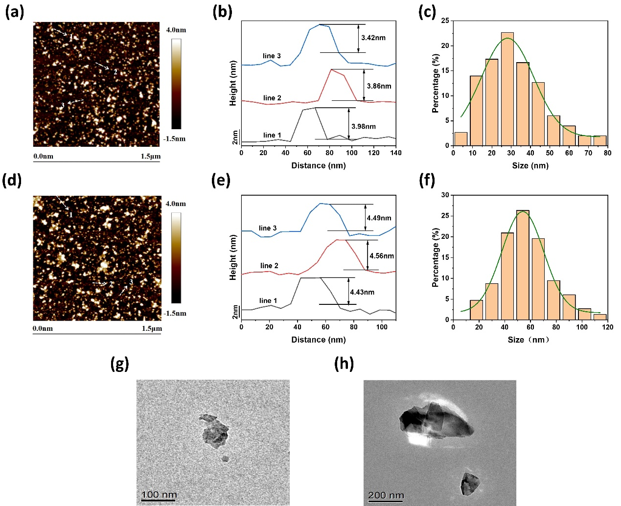

Figure S1. (a) Representative AFM morphology of SBPNS-BSA-FITC. (b) The corresponding thickness of SBPNS-BSA-FITC (n = 3). (c) Histogram of particle size distribution corresponding to SBPNS-BSA-FITC. (d) Representative AFM morphology of LBPNS-BSA-FITC. (e) The corresponding thicknesses of LBPNS-BSA-FITC (n =3). (f) Histogram of particle size distribution corresponding to LBPNS-BSA-FITC (The histograms were developed by counting each sample (200 - 300) and showing Gaussian fitted curves). (g) Representative TEM morphology of SBPNS. (h) Representative TEM morphology of LBPNS.

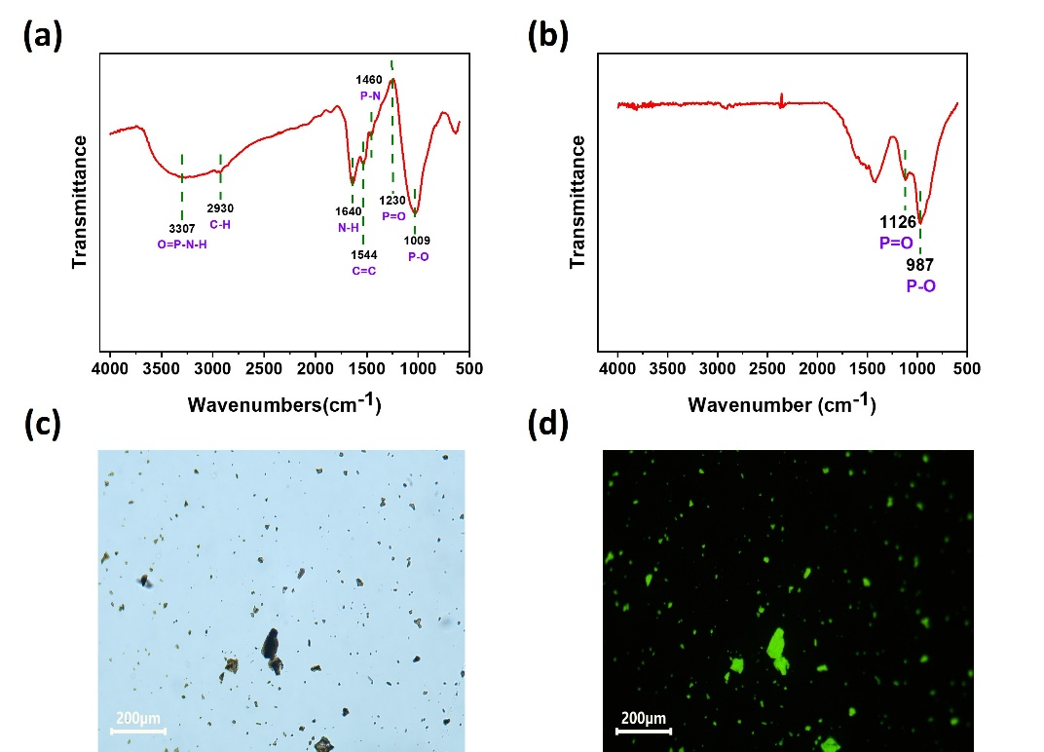

Figure S2. (a) Microscopic infrared mapping (FTIR) of BPNS-BSA-FITC. (b) Micro-infrared mapping (FTIR) of BPNS. (c) Bright field image of BPNS-BSA-FITC. (d) Fluorescence picture of BPNS-BSA-FITC (Ex = 488 nm).

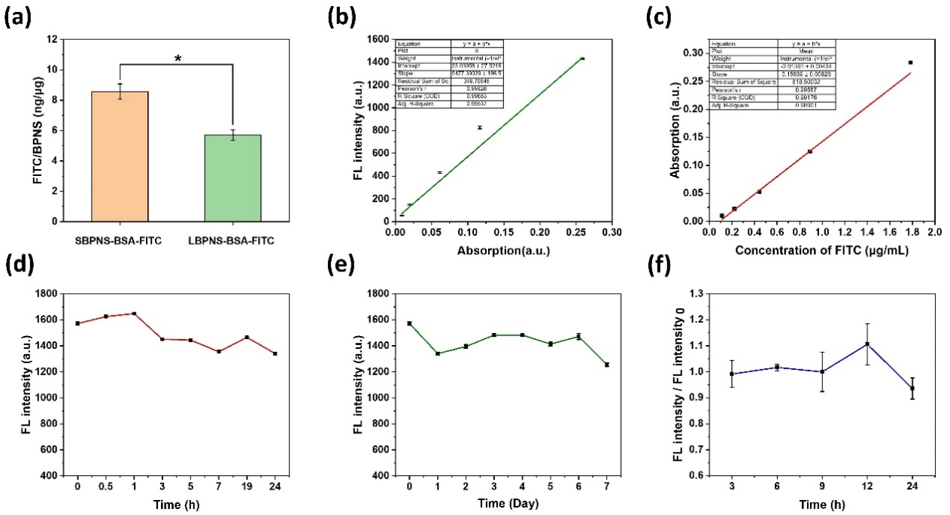

Figure S3. (a) FITC loading of SBPNS-BSA-FITC and LBPNS-BSA-FITC (Ex = 490 nm, Em = 520 nm, n = 3). (b) Standard curve of UV absorbance versus fluorescence intensity of BPNS-BSA-FITC (n = 3). (c) Standard curve of UV absorbance versus fluorescence intensity of FITC concentration (Abs = 490 nm, n = 3). (d) Fluorescence intensity of BPNS-BSA-FITC at 0 - 24 h (n= 3). (e) Fluorescence intensity of BPNS-BSA-FITC during 0 - 7 d (n = 3). (f) Ratio of fluorescence intensity of BPNS-BSA-FITC after washing to initial fluorescence intensity in 0 - 24 h (n = 3).

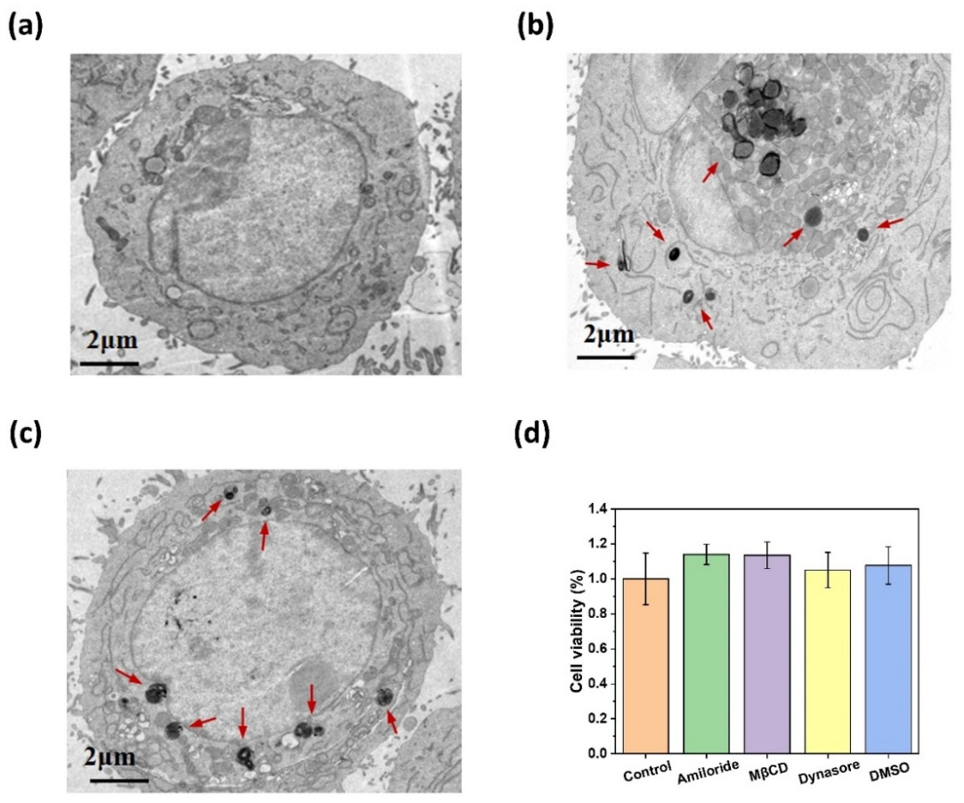

Figure S4. (a) Typical transmission electron micrograph (TEM) of A549 cells not treated with SBPNS-BSA-FITC. (b) Typical transmission electron micrograph (TEM) of SBPN-BSA-FITC in A549 cells. (c) Typical transmission electron micrograph (TEM) of LBPN-BSA-FITC in A549 cells. (d) Cell viability was measured by Amiloride, MβCD, Dynasore, and solvent DMSO corresponding to CCK-8 reagent (n = 3).

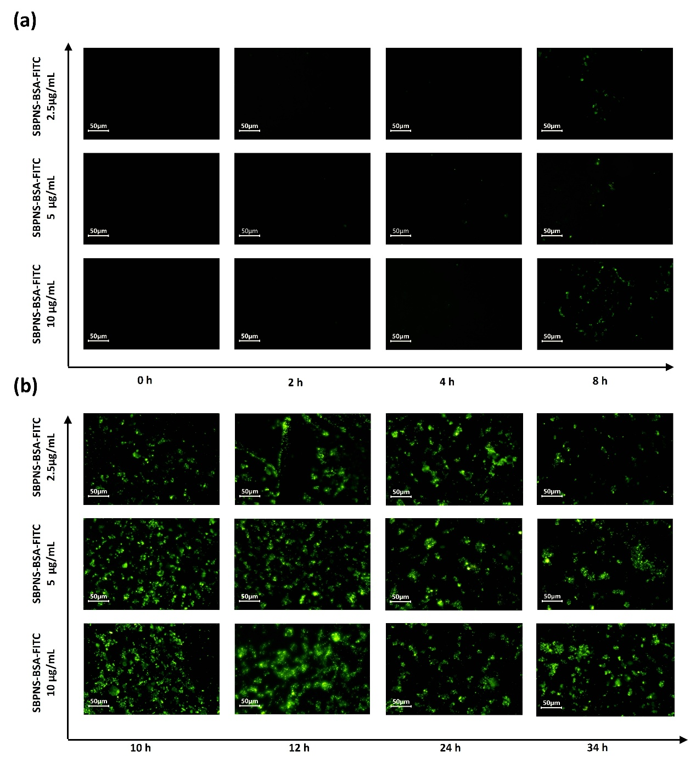

Figure S5. (a) Fluorescence images of cells ingesting 10, 5, 2.5 μg/mL of SBPNS-BSA-FITC within 0 - 8 h (Ex = 488 nm). (b) Fluorescence images of cells ingesting 10, 5, 2.5 μg/mL of SBPNS-BSA-FITC within 10 - 34 h (Ex = 488 nm).

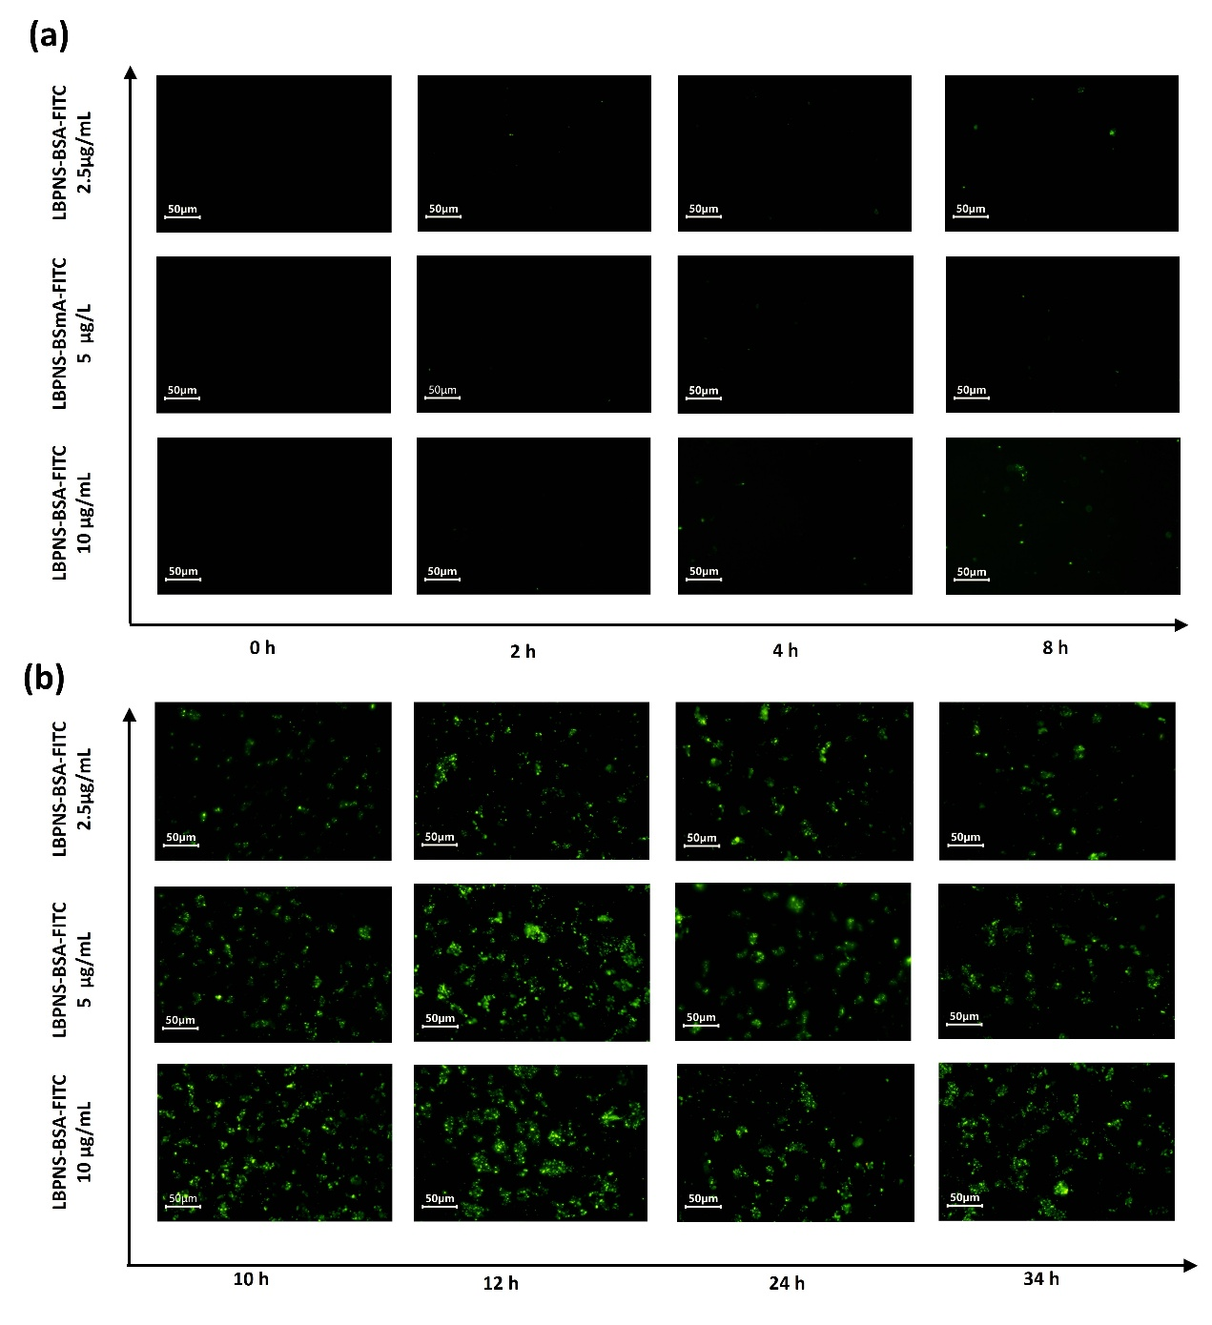

Figure S6. (a) Fluorescence images of cells ingesting 10, 5, 2.5 μg/mL of LBPNS-BSA-FITC within 0 - 8 h (Ex = 488 nm). (b) Fluorescence images of cells ingesting 10, 5, 2.5 μg/mL of LBPNS-BSA-FITC within 10 - 34 h (Ex = 488 nm).

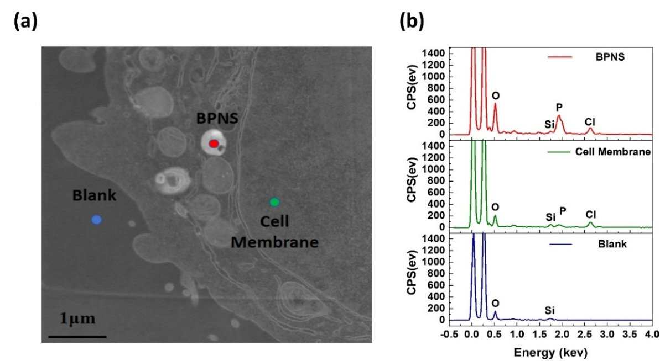

Figure S7. (a) Typical transmission electron micrograph (TEM) of BPNS inside a cell (red: BPNS; green: cell membrane; blue: blank). (b) Elemental point measurements at the corresponding positions in Figure. S7a.

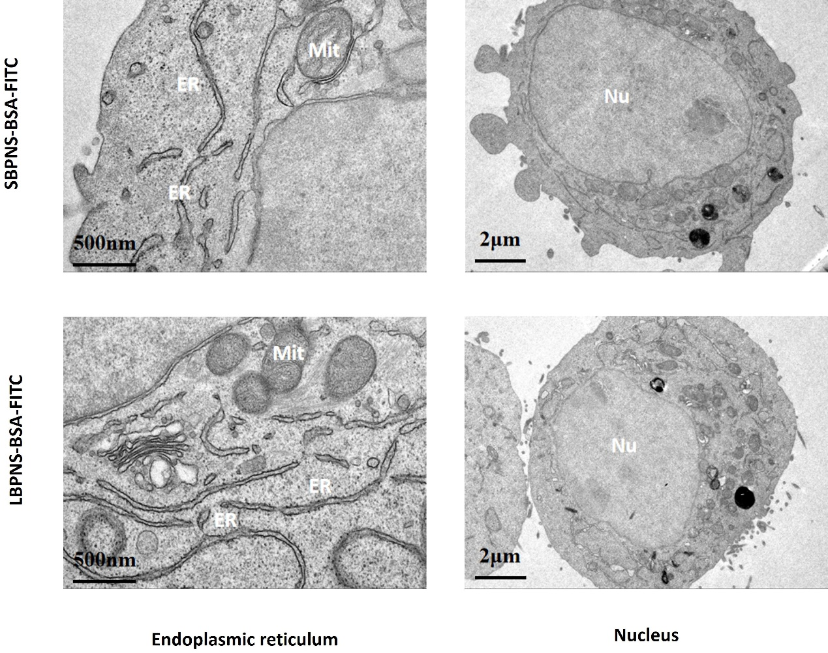

Figure S8. Typical transmission electron microscopy (TEM) of the Endoplasmic Reticulum, Nucleus, and other organelles of SBPNS-BSA-FITC and LBPNS-BSA-FITC after 24 h of exposure.

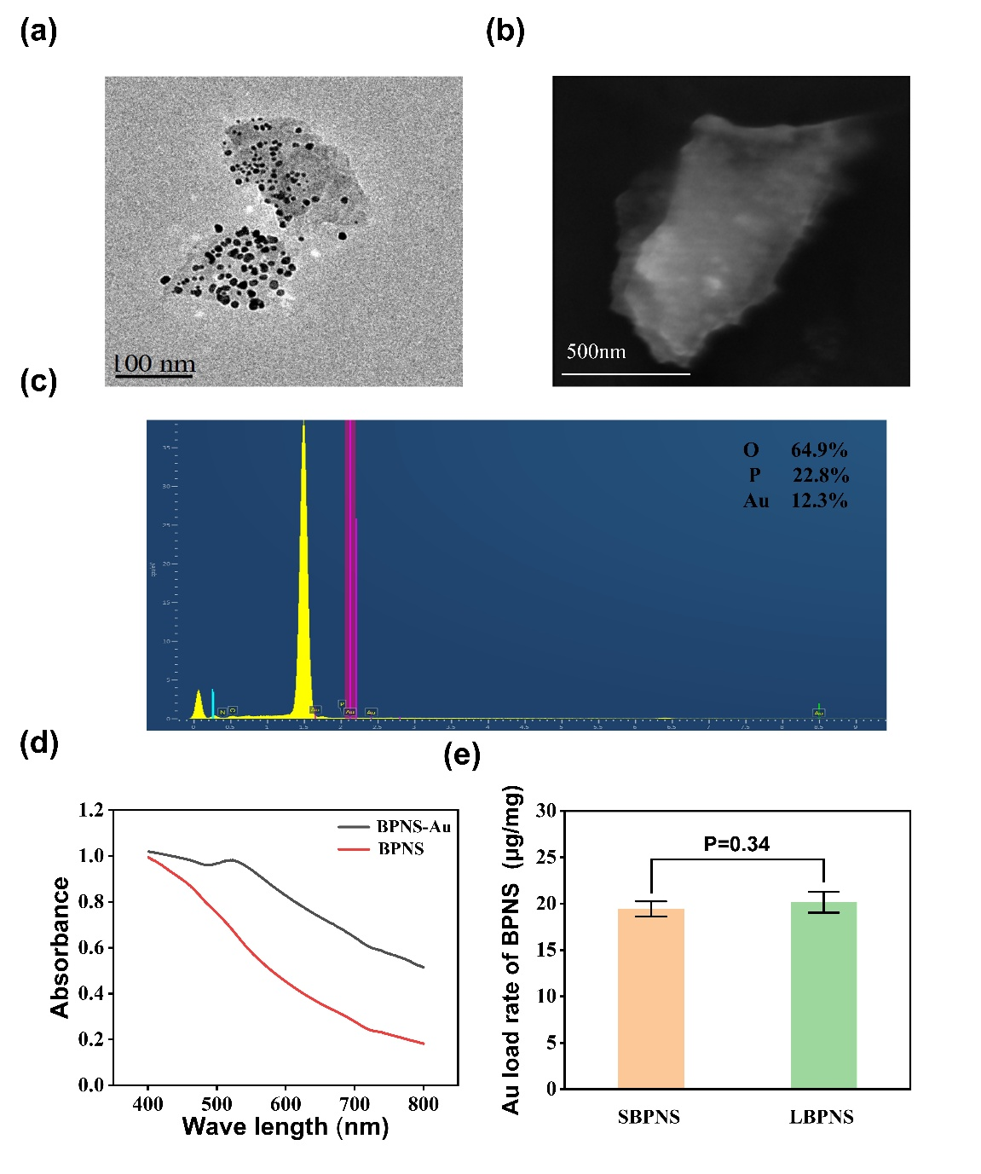

Figure S9. (a) TEM morphology characterization of BPNS-Au. (b) SEM morphology characterization of BPNS-Au. (c) EDS spectroscopy analysis of BPNS-Au. (d) UV-Vis spectra of BPNS and BPNS-Au (n = 3). (e) Au loading rate of BPNS (n = 3).

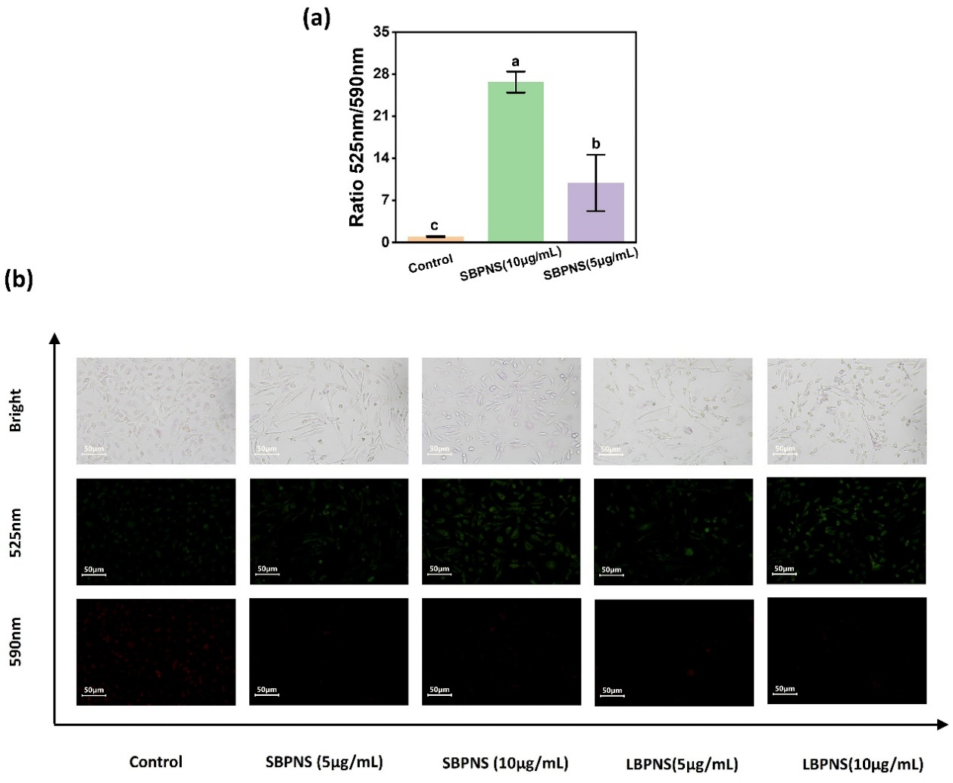

Figure S10. (a) Effects of different concentrations of SBPNS on mitochondrial membrane potential (MMP) after exposure of cells (green fluorescence at 525 nm because of low mitochondrial membrane potential JC-10 in the form of green fluorescent monomers, red fluorescence at 590 nm because of high mitochondrial membrane potential JC-10 in the form of red fluorescent cluster) (n = 3). (b) Effects of different concentrations of SBPNS and LBPNS on mitochondrial membrane potential (MMP) after exposure of cells under an inverted fluorescence microscope (Em = 525 nm and Em = 590 nm).

Table S1. Diagram of changes in intracellular ROS content (Figure 5c) corresponding to flow data.

 | Sample | Gate | Count | % All | Median X
1 | SBPNS | P2 | 9,405 | 93.48 | 107
2 | LBPNS | P2 | 9,265 | 91.52 | 98
3 | Control | P2 | 9,309 | 92.74 | 80

