Supporting Information
Experimental and Data-driven Investigation of Hydrophilic and Hydrophobic Ionic Liquids for Supercapacitors
Qiutong Chen¹, Jifeng Wang¹, Ying Wang^{1*}
¹State Key Laboratory of Molecular Engineering of Polymers, Department of Macromolecular Science, Fudan University, Shanghai, 200438, China
*Corresponding author (email: wying@fudan.edu.cn)

Table 1. The number of IL pairs and water molecules in IL-water mixture with different IL: H₂O ratios for the MD simulations.
Name of IL-water mixture | [C₂mim]⁺ | Anion | H₂O
TFO+0 | 480 | 480 | 0
TFO+5 | 480 | 480 | 25
TFO+10 | 480 | 480 | 50
TFO+50 | 480 | 480 | 250
TFO+100 | 480 | 480 | 500
TFSI+0 | 350 | 350 | 0
TFSI+5 | 350 | 350 | 25
TFSI+10 | 350 | 350 | 50
TFSI+50 | 350 | 350 | 250
TFSI+100 | 350 | 350 | 500

Table 2. Calculated HOMO, LUMO, and the HOMO-LUMO energy gaps for the five ILs.
Name | HOMO (Hatree) | LUMO (Hatree) | HOMO LUMO Gap (eV)
[C₂mim][TFO] | -0.23885 | -0.04102 | 5.380976
[C₂mim][DCA] | -0.20012 | -0.04859 | 4.121616
[C₂mim][BF₄] | -0.29673 | -0.03966 | 6.992304
[C₂mim][FSI] | -0.28174 | -0.05716 | 6.108576
[C₂mim][TFSI] | -0.27353 | -0.0463 | 6.180656

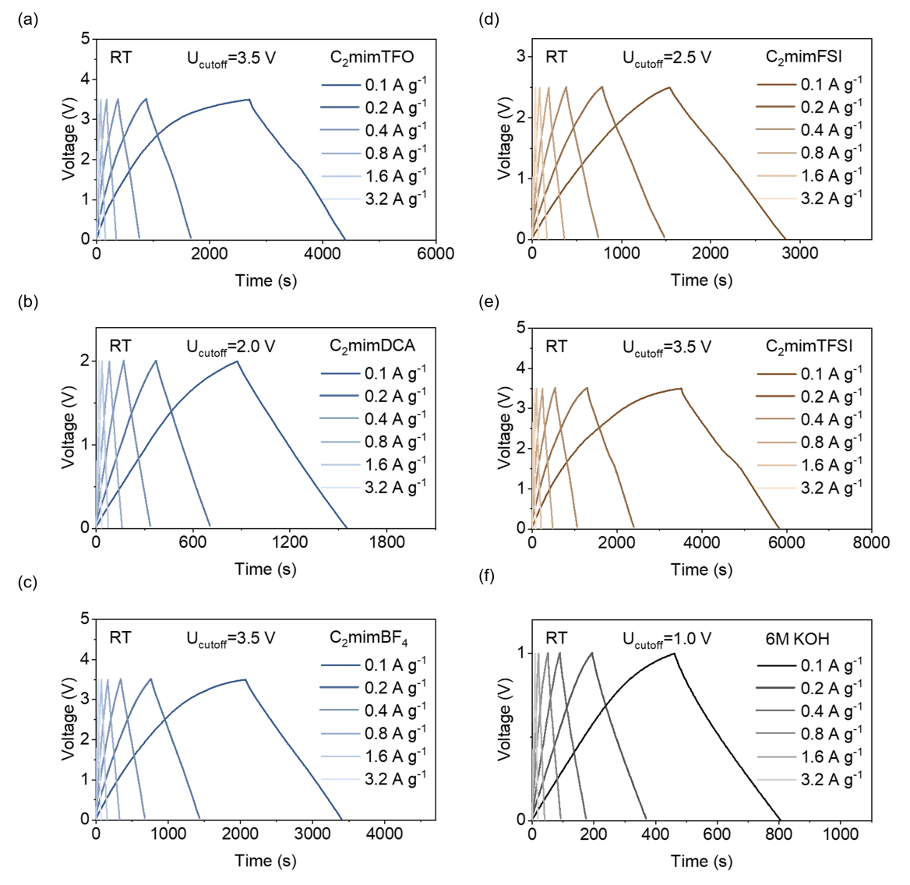
Figure S1. The Galvanostatic charge–discharge (GCD) curves of (a) [C₂mim][TFO], (b) [C₂mim][DCA], (c) [C₂mim][BF₄], (d) [C₂mim][FSI], (e) [C₂mim][TFSI], (f) 6M KOH under increasing s current densities of 0.1, 0.2, 0.4, 0.8, 1.6, and 3.2 A g⁻¹.

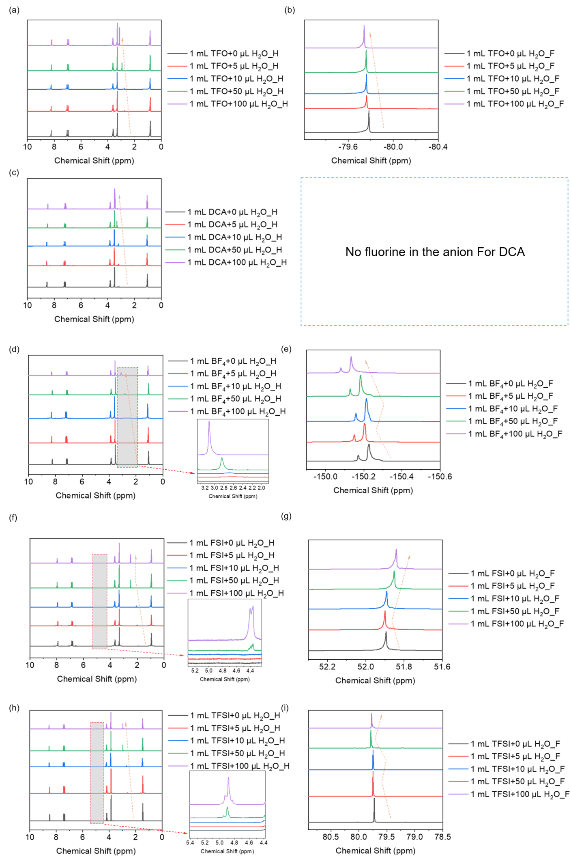
Figure S2. The 1D NMR spectra of IL-water mixtures. ¹H NMR (a) and ¹⁹F NMR (b) spectra of [C₂mim][TFO] at different water contents. ¹H NMR (c) spectra of [C₂mim][DCA] at different water contents. ¹H NMR (d) and ¹⁹F NMR (e) spectra of [C₂mim][BF₄] at different water contents. ¹H NMR (f) and ¹⁹F NMR (g) spectra of [C₂mim][FSI] at different water contents. ¹H NMR (h) and ¹⁹F NMR (i) spectra of [C₂mim][FSI] at different water contents.

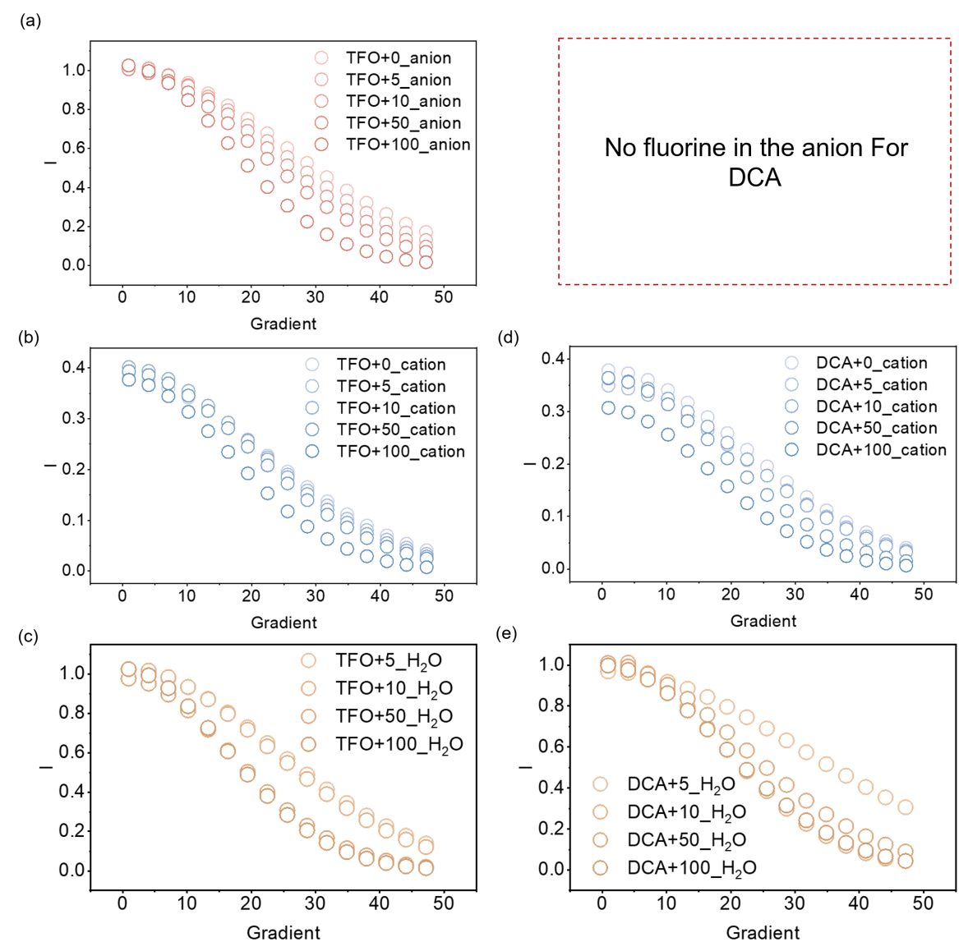
Figure S3. The PFG-NMR results of anion (a) , cation (b) and H₂O (c) of [C₂mim][TFO] at different water contents. PFG-NMR spectra of cation (d) and H₂O (e) of [C₂mim][DCA] at different water contents.

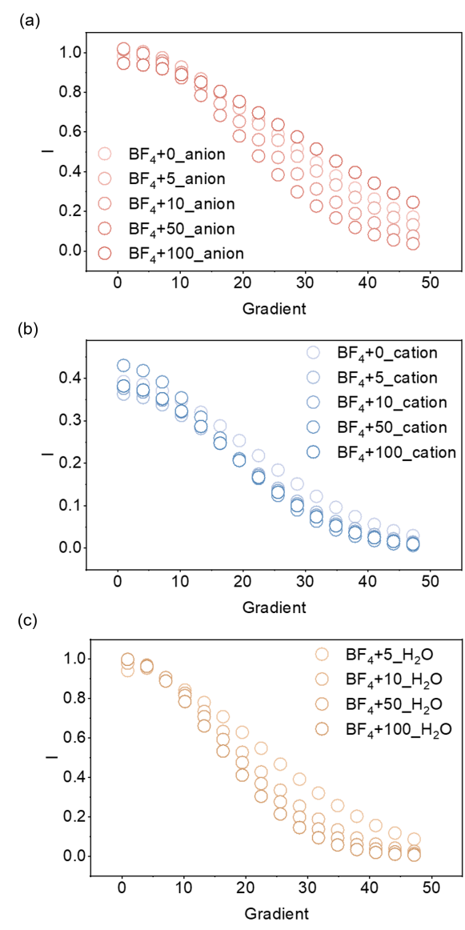
Figure S4. The PFG-NMR results of anion (a), cation (b) and H₂O (c) of [C₂mim][BF₄] at different water contents.

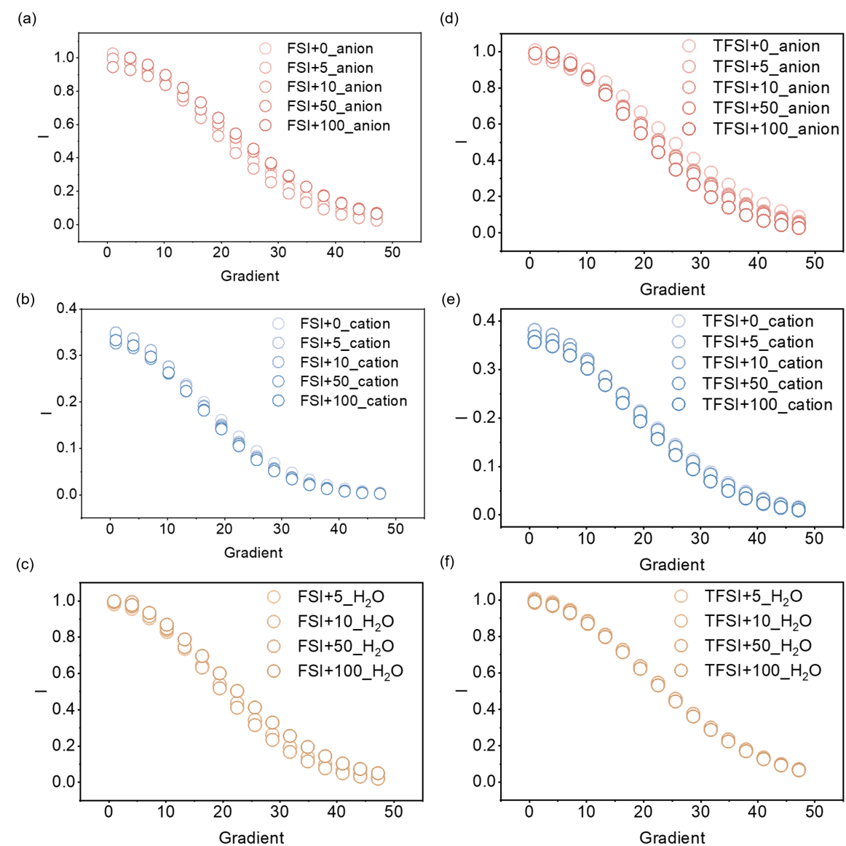

Figure S5. The PFG-NMR results of anion (a) , cation (b) and H₂O (c) spectra of [C₂mim][FSI] at different water contents. PFG-NMR spectra of anion (a) , cation (b) and H₂O (c) spectra of [C₂mim][TFSI] at different water contents.

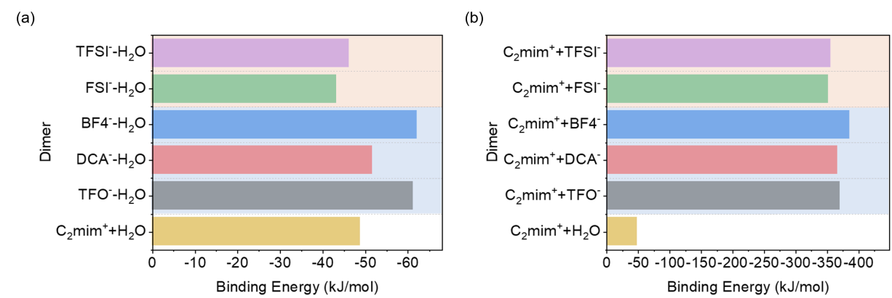
Figure S6. The binding energy (a) between the ions and water; (b) [C₂mim]⁺ with anions and water.

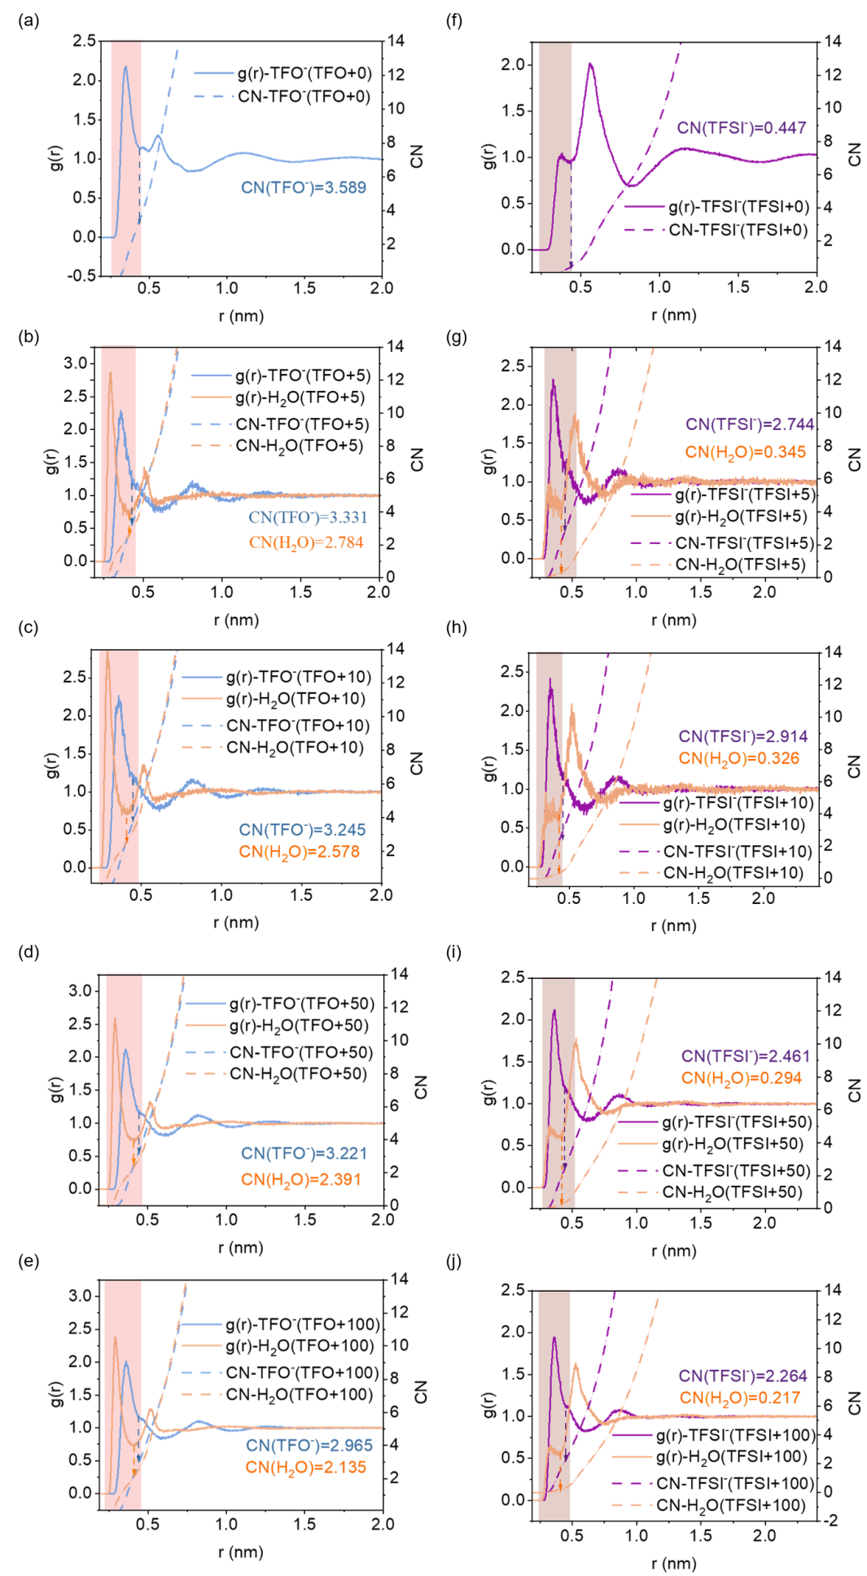
Figure S7. (a-e) The radial distribution functions (RDF) and coordination numbers (CN) of anions and H₂O, centered with [C₂mim]⁺, in [C₂mim][TFO] at different water contents. (f-j) RDF and CN of anions and H₂O, centered with [C₂mim]⁺, in [C₂mim][TFSI] at different water contents. Calculations are based on the atomcharge.
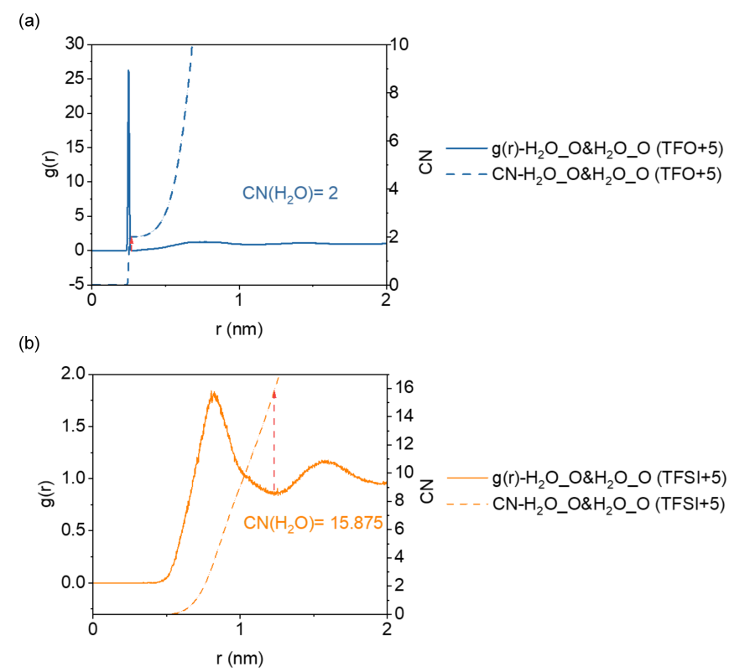
Figure S8. RDF and CN between water molecules in the hydrophilic (TFO+5) (a) and hydrophobic (TFSI+5) (b) IL–H₂O mixtures. Calculations are based on the oxygen atoms of water molecules (O-O).

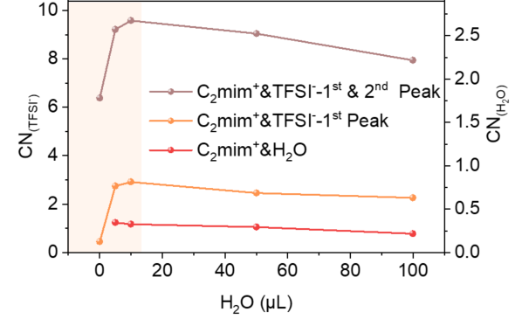
Figure S9. CN between [C₂mim]⁺ and anions based on integration over the first peak and the first & second peaks of the RDF, as well as CN between [C₂mim]⁺ and H₂O in [C₂mim][TFSI] at varying water contents.

